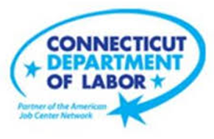

**NEW WEEKLY JOB POSTINGS FROM   
HELP WANTED ONLINE  
Office of Research**

**Week Ending May 6th, 2023: New Ads Up 5% Over The Week**WETHERSFIELD, May 12th, 2023 – During the week ending May 6th, 2023, there were 8,818 new postings, up 424 new ads or +5% from a week ago. Over the past week, much of this increase can be attributed to growth in Educational Services (+378 new ads), Accommodation & Food Services (+122 new ads), and Retail Trade (+104 new ads). In total, 13 industries grew by a combined 816 new ads over the week and 8 industries fell by a combined 392 ads. The largest industry decrease occurred in Health Care & Social Assistance, down 132 new ads. Employers with large over-the-week increases include Walmart (+282 new ads), Globe Companies LLC (+131 new ads), and the YMCA (+80 new ads). The three occupations with the largest over-the-week increase were Registered Nurses (+163 new ads), Postsecondary Teachers (+136 new ads), and Automotive Service Technicians and Mechanics (+71 new ads). The overall increase in Connecticut new ads is shown below to trend differently than the U.S. in recent weeks. From March to early April, both geographies exhibited similar week-to-week total new ad change. In recent weeks the US has trended downward while Connecticut has seen relatively consistent weekly new ad increases, up from 7,591 new ads during the week ending April 15th through the week ending May 6th.   
  
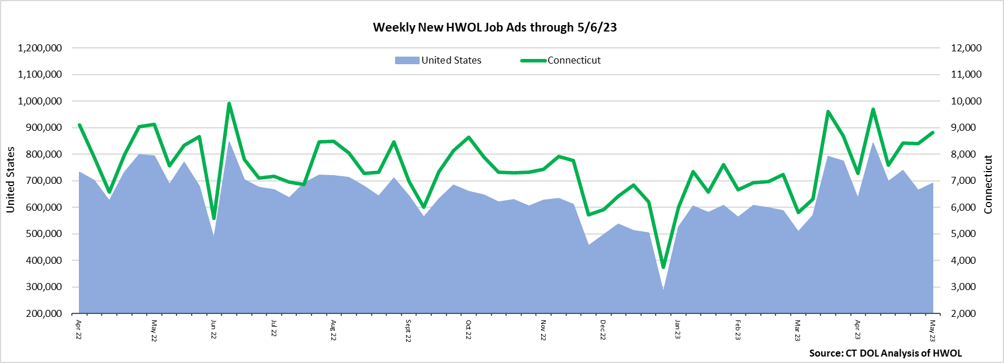  
  
**Industries** with the most new postings include Health Care & Social Assistance, Retail Trade, and Educational Services.

**Occupations** with the most new postings include Registered Nurses, Postsecondary Teachers, and Automotive Service Technicians & Mechanics.

**Employers** with the most new postings include Hartford Healthcare, Walmart, and Yale-New Haven Health System.

**The three industries with the most new job postings were:**

* **Health Care & Social Assistance** (2,157 new postings, -6% over the week)
* **Retail Trade** (976 new postings, +12% over the week)
* **Educational Services** (726 new postings, +109% over the week)

   
 During the week ending May 6th, 13 industries decreased and 8 increased. Growing industries include Educational Services, Accommodation & Food Services, and Retail Trade. Among the three increasing industries, the largest employer gains were respectively had at East Hartford Public Schools (+54 new ads), Barcelona Wine Bar (+23 new ads), and Walmart (+282 new ads). Decreasing industries include Health Care & Social Assistance, Wholesale Trade, and Finance & Insurance. The largest respective employer new ad losses in those industries occurred at Hartford Healthcare (-106 new ads), Crossmark (-33 new ads), and Humana (-53 new ads). Over four weeks, 13 industries are down, and total ads are down by 844 new ads. Four weeks ago had the highest overall ad count since June 2022.  
  
 For more information on total job ads by industry for Connecticut and its labor market areas, see the monthly report available here: <https://www1.ctdol.state.ct.us/lmi/hwol.asp>

**New Job Postings by Occupation** 

**The occupations with the most new postings were:**

* Registered Nurses ( 869 new postings, +23% over the week)
* Retail Salespersons (283 new postings, +23% over the week)
* Supervisors of Retail Sales Workers (237 new postings, +32% over the week)

**Employers with the Most New Job Postings** Employers with the most new job postings during the week ending May 6th were mostly within Retail Trade, Health Care & Social Assistance, and Finance & Insurance. The employers with the most new ads in these three respective industries were Walmart (287 new ads), Hartford Healthcare (321 new ads), and UnitedHealth Group (83 new ads). Overall, the 25 employers with the most ads account for a combined 25 percent of total new ads. Among the 25 employers shown above, 17 increased over the week and 8 decreased.   
  
**What is HWOL?**The **Conference Board Help Wanted Online**® Data Series (HWOL) measures the number of new, first-time Online job postings and jobs reposted from the previous month for over 16,000 Internet job boards, corporate boards, and smaller job sites that serve niche markets and smaller geographic areas. To view more HWOL data, go to: <https://www1.ctdol.state.ct.us/lmi/hwol.asp>